**WEEK 2 - JUnit Testing Exercises**

**MANDATORY EXERCISES**

**Exercise 1: Setting Up Junit:**

**src/main/java:**

**App.Java:**

package com.example.JunitDemo;

public class App {

public int add(int a, int b) {

return a + b;

}

}

**AppTest.java**

package com.example.JunitDemo;

import org.junit.jupiter.api.Test;

import static org.junit.jupiter.api.Assertions.*assertEquals*;

public class AppTest {

@Test

public void testAdd() {

App app = new App();

int result = app.add(4, 6);

System.*out*.println("Result of add(4, 6): " + result);

*assertEquals*(10, result);

}

}

**OUTPUT:**

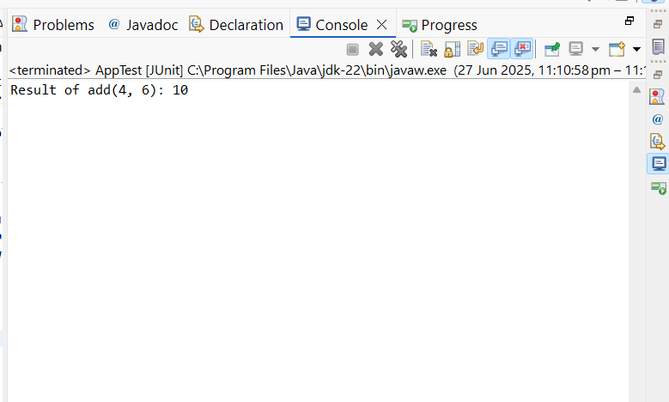

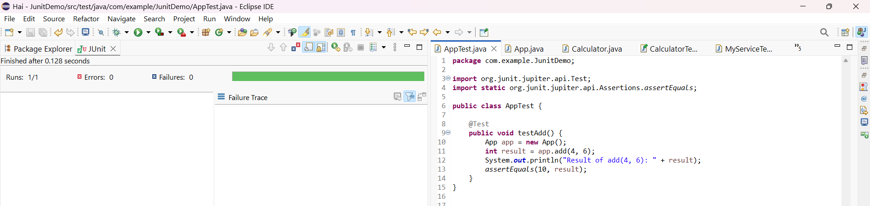

**Exercise 3: Assertions in Junit**

**CODE:**

package com.example.JunitDemo;

import org.junit.jupiter.api.Test;

import static org.junit.jupiter.api.Assertions.*;

public class AssertionsTest {

@Test

public void testAssertions() {

*assertEquals*(5, 2 + 3);

*assertTrue*(10 > 5);

*assertFalse*(5 < 1);

*assertNull*(null);

*assertNotNull*("JUnit");

}

}

**OUTPUT:**

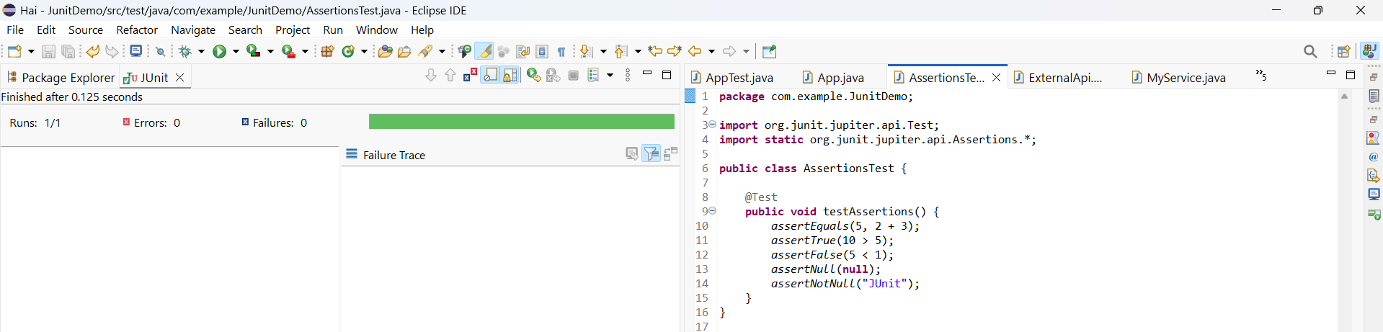

**Exercise 4: Arrange-Act-Assert (AAA) Pattern, Test Fixtures, Setup and Teardown Methods in Junit:**

**CODE:**

**Calculator.Java:**

package com.example.JunitDemo;

public class Calculator {

public int add(int a, int b) {

return a + b;

}

public int multiply(int a, int b) {

return a * b;

}

}

**CalculatorTest.java:**

package com.example.JunitDemo;

import org.junit.jupiter.api.*;

import static org.junit.jupiter.api.Assertions.*;

public class CalculatorTest {

private Calculator calculator;

@BeforeEach

public void setUp() {

calculator = new Calculator();

System.*out*.println("Before Each Test");

}

@AfterEach

public void tearDown() {

System.*out*.println("After Each Test");

}

@Test

public void testAddition() {

int result = calculator.add(2, 3);

*assertEquals*(5, result);

}

@Test

public void testMultiplication() {

int result = calculator.multiply(4, 3);

*assertEquals*(12, result);

}

}

**OUTPUT:**

